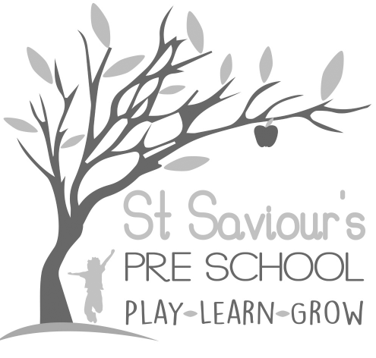
6.6 FOOD HYGIENE

Written by: Claire Toms and Tina Alder Date: 1.09.22 – reviewed 28.8.25

Policy Statement
We provide snacks for children and maintain the highest possible food hygiene standards with regard to the purchase, storage, preparation, and serving of food. We follow the updated EYFS 2025 guidance on nutrition, hygiene, and reducing the risk of cross-contamination.

Procedures
• We use reliable, reputable suppliers for the food we purchase and ensure that all food is nutritionally appropriate for children.
• Food is stored at correct temperatures, checked to ensure it is in-date, and protected from contamination by pests, rodents, mould, or cross-contamination with allergens.
• Packed lunches are stored in a cool place and served to children within four hours of preparation at home.
• Food preparation areas are cleaned thoroughly before and after use.
• All surfaces are clean, non-porous, and disinfected regularly.
• All utensils, crockery, and equipment are clean, stored safely, and checked regularly.
• Waste food is disposed of daily in line with hygiene regulations.
• Cleaning materials and other dangerous substances are stored securely out of reach of children.
• Children do not have unsupervised access to the kitchen.
• When children take part in cooking activities, they are always supervised and taught safe food handling practices, including hygiene, hand-washing, and avoiding cross-contamination.
• Children understand the importance of hand washing before and after handling food, and simple hygiene rules.
• Children are not allowed near hot surfaces, hot water, or electrical equipment, and do not have unsupervised access to kitchen appliances such as blenders.

Reporting of Food Poisoning
Food poisoning can occur for several reasons; not all cases of sickness or diarrhoea are due to food poisoning, and not all are reportable.
• Where children and/or adults have been diagnosed by a GP or hospital doctor as suffering from food poisoning and it appears possible that the source of the outbreak is within our setting, the manager will contact the Environmental Health Department immediately and comply with any investigation.
• We notify Ofsted as soon as reasonably practicable, and always within 14 days, of any confirmed cases of food poisoning affecting two or more children looked after on the premises.
• Staff and children’s families will be informed promptly of any suspected outbreaks, and guidance from Public Health England or local authorities will be followed.
• We review our hygiene procedures and risk assessments after any outbreak to minimise future risk, including checks on food handling, storage, and staff training.

